

Name: Saim Nisar
Class: ADCS 2A
Roll No: 2500626
Subject: Web Technology

Lab Task 1
Code:
<!DOCTYPE html>
<html lang="en">
<head>
<meta charset="UTF-8">
<title>Even or Odd Checker</title>
</head>
<body>

<label>Enter a number:</label>
<input type="number" id="num1">
<button onclick="checkNumber()">Check</button>

<p id="result"></p>

<script>
function checkNumber() {
let value = document.getElementById("num1").value;
let result = document.getElementById("result");

if (value === "") {
result.innerText = "Please enter a number.";
result.style.color = "red";
return;
}

let n = Number(value);

if (n % 2 === 0) {
result.innerText = "Number is Even";
result.style.color = "green";
} else {
result.innerText = "Number is Odd";
result.style.color = "green";
}
}
</script>

</body>
</html>

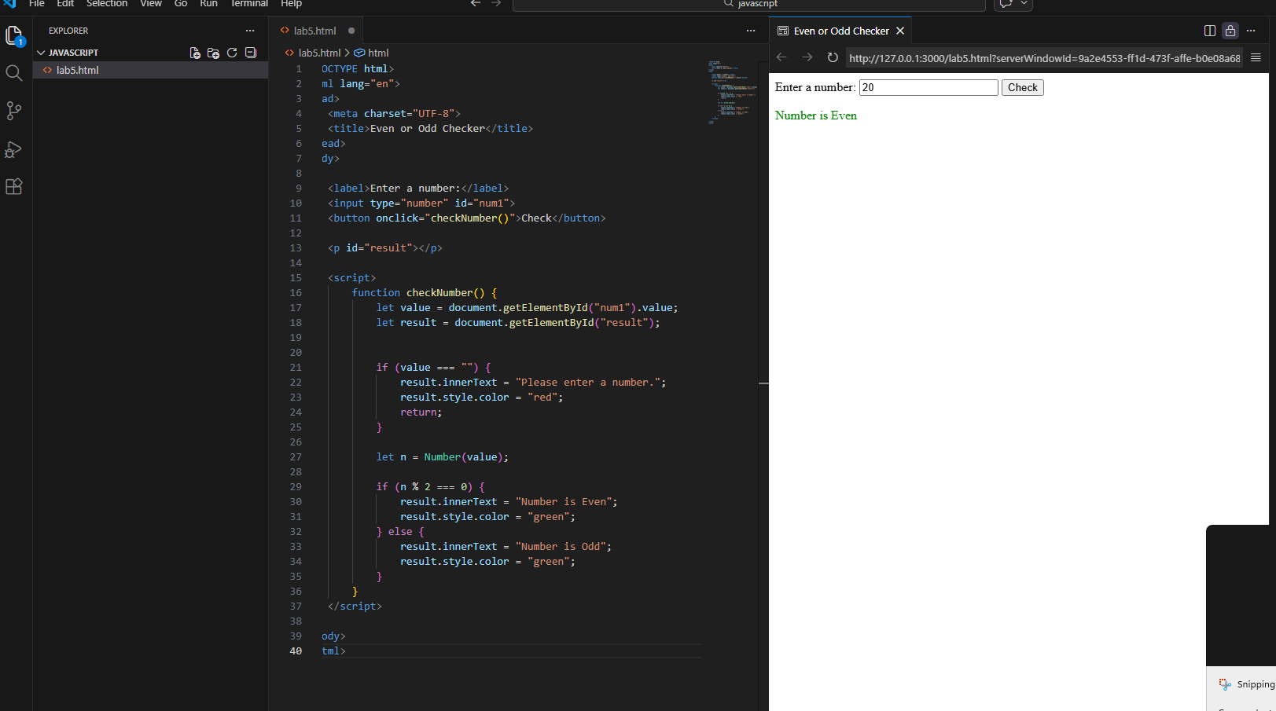

Lab Task 2

Code:
<!DOCTYPE html>
<html>
<head>
<title>Simple Calculator</title>
<style>
body {
font-family: Arial;
text-align: center;
margin-top: 50px;
}

input {
padding: 8px;
margin: 5px;
width: 150px;
}

button {
padding: 8px 12px;
margin: 5px;
cursor: pointer;
}

#result {
font-size: 20px;
font-weight: bold;
margin-top: 15px;
}
</style>
</head>
<body>

<h2>Simple Calculator</h2>

<input type="number" id="num1" placeholder="Enter first number">
<input type="number" id="num2" placeholder="Enter second number">
<br>

<button onclick="calculate('+')">Add</button>
<button onclick="calculate('-')">Subtract</button>
<button onclick="calculate('*')">Multiply</button>
<button onclick="calculate('/')">Divide</button>

<div id="result"></div>

<script>
function calculate(operator) {

let value1 = document.getElementById("num1").value;
let value2 = document.getElementById("num2").value;
let resultDiv = document.getElementById("result");

// Check if inputs are empty
if (value1 === "" || value2 === "") {
resultDiv.innerHTML = "Error: Please enter both numbers.";
resultDiv.style.color = "red";
return;
}

// Convert using Number constructor
let num1 = Number(value1);
let num2 = Number(value2);

// Check if valid numbers
if (isNaN(num1) || isNaN(num2)) {
resultDiv.innerHTML = "Error: Please enter valid numbers.";
resultDiv.style.color = "red";
return;
}

let result;

switch(operator) {
case '+':
result = num1 + num2;
break;

case '-':
result = num1 - num2;
break;

case '*':
result = num1 * num2;
break;

case '/':
if (num2 === 0) {
resultDiv.innerHTML = "Error: Cannot divide by zero.";
resultDiv.style.color = "red";
return;
}
result = num1 / num2;
break;
}

resultDiv.innerHTML = "Result: " + result;
resultDiv.style.color = "green";
}
</script>

</body>
</html>

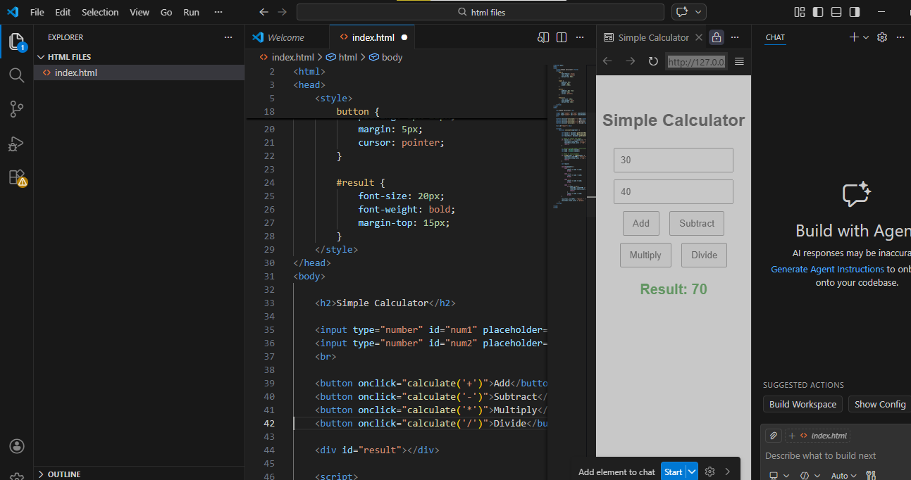

Task 3

Code:
<!DOCTYPE html>
<html>
<head>
<title>Array Based Web Page</title>

<style>
body {
font-family: Arial;
text-align: center;
margin-top: 50px;
}

.container {
width: 450px;
margin: auto;
padding: 20px;
border: 2px solid black;
border-radius: 10px;
}

button {
padding: 8px 15px;
margin-top: 15px;
cursor: pointer;
}

#results {
margin-top: 20px;
font-size: 18px;
}

.success {
color: green;
}
</style>
</head>

<body>

<div class="container">
<h2>Array Operations</h2>

<button onclick="processArray()">Show Results</button>

<div id="results"></div>
</div>

<script>

function processArray() {

let numbers = [12, 7, 25, 40, 3, 18];

let resultsDiv = document.getElementById("results");

// Display original array
let output = "<p><b>Original Array:</b> " + numbers.join(", ") + "</p>";

// 2. Calculate Sum
let sum = 0;
for (let i = 0; i < numbers.length; i++) {
sum += numbers[i];
}

output += "<p><b>Sum of Numbers:</b> " + sum + "</p>";

let largest = numbers[0];

for (let i = 1; i < numbers.length; i++) {
if (numbers[i] > largest) {
largest = numbers[i];
}
}

output += "<p><b>Largest Number:</b> " + largest + "</p>";

// 4. Reverse Array
let reversed = numbers.slice().reverse();

output += "<p><b>Reversed Array:</b> " + reversed.join(", ") + "</p>";

// Show all results on webpage
resultsDiv.innerHTML = output;
resultsDiv.className = "success";
}

</script>

</body>
</html>

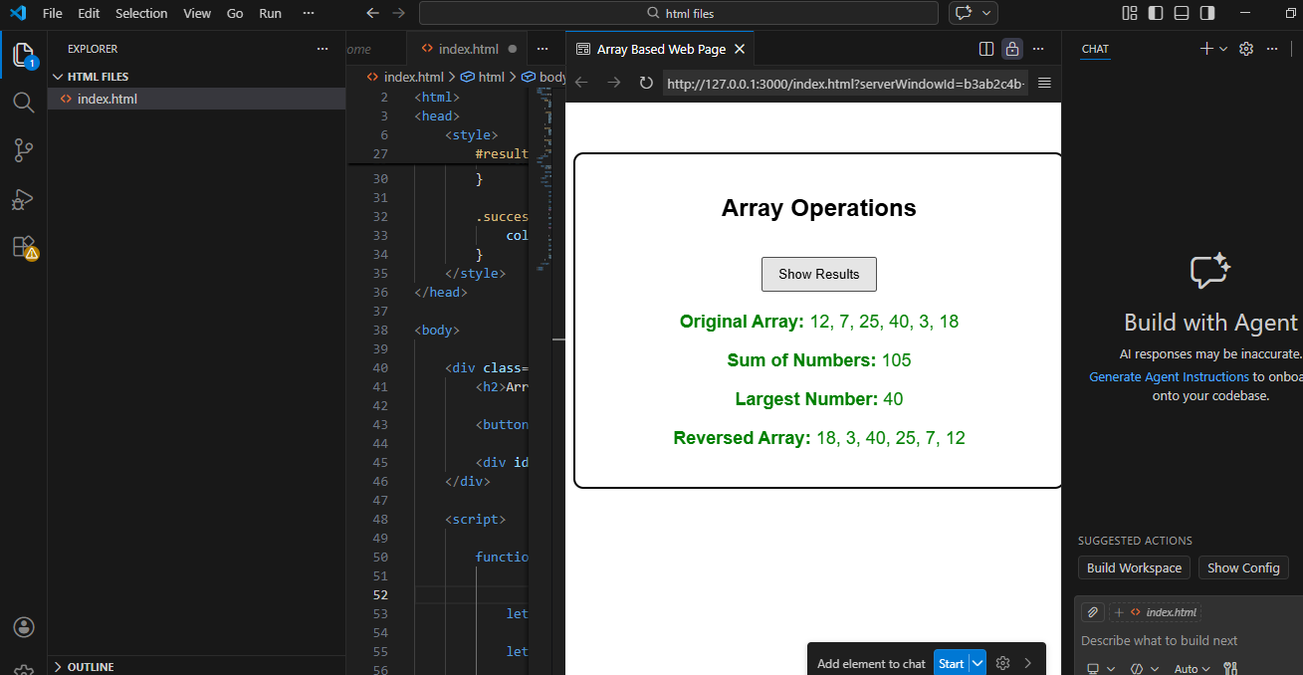

TASK 4
<!DOCTYPE html>
<html>
<head>
<title>Student Report</title>

<style>
body {
font-family: Arial;
text-align: center;
margin-top: 50px;
}

.container {
width: 500px;
margin: auto;
padding: 20px;
border: 2px solid black;
border-radius: 10px;
}

button {
padding: 8px 15px;
margin-bottom: 15px;
cursor: pointer;
}

#results {
font-size: 18px;
}

.success {
color: green;
}

table {
width: 100%;
border-collapse: collapse;
margin-top: 10px;
}

table, th, td {
border: 1px solid black;
}

th, td {
padding: 8px;
}

th {
background-color: black;
color: white;
}
</style>
</head>

<body>

<div class="container">
<h2>Student Marks System</h2>

<button onclick="processStudents()">Show Results</button>

<div id="results"></div>
</div>

<script>

function processStudents() {

let students = [
{ name: "Ali", marks: 85 },
{ name: "Sara", marks: 92 },
{ name: "Ahmed", marks: 78 }
];

let resultsDiv = document.getElementById("results");

let output = "<h3>Students List</h3>";
output += "<table>";
output += "<tr><th>Name</th><th>Marks</th></tr>";

let totalMarks = 0;
let topper = students[0];

// 2️⃣ Loop over array of objects
for (let i = 0; i < students.length; i++) {

output += "<tr>";
output += "<td>" + students[i].name + "</td>";
output += "<td>" + students[i].marks + "</td>";
output += "</tr>";

totalMarks += students[i].marks;

// 4️⃣ Find topper
if (students[i].marks > topper.marks) {
topper = students[i];
}
}

output += "</table>";

// 3️⃣ Calculate average marks
let average = totalMarks / students.length;

output += "<p><b>Average Marks:</b> " + average.toFixed(2) + "</p>";
output += "<p><b>Topper:</b> " + topper.name +
" (" + topper.marks + " marks)</p>";

// Display all results
resultsDiv.innerHTML = output;
resultsDiv.className = "success";
}

</script>

</body>
</html>

